**Chegou o Natal! Jesus Nasceu!**

[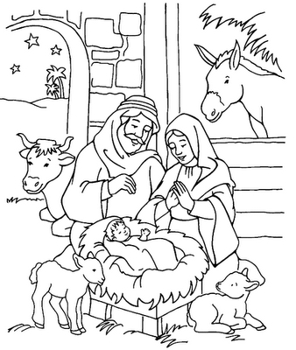](http://www.google.com.br/url?sa=i&source=images&cd=&cad=rja&docid=xTFUykeoZlyxDM&tbnid=lrcQgIv5DlwCkM:&ved=0CAgQjRwwAA&url=http%3A%2F%2Fpintarosdesenhos.blogspot.com%2F2012%2F04%2Fdesenhos-para-colorir-natal.html&ei=47dOUteoCtW-4AOYmICgDQ&psig=AFQjCNHDeuPy-fNMBR7y_bzA3cc8fts4NQ&ust=1380976995212918)

